# ETSI’s New Working Methods Initiative in brief

# Problem to be solved:

ETSI has a very successful record in the collaborative production and publication of its deliverables, which is now reaching some practical limits.

3GPP:

* Volume of contributions and Change Requests are constantly increasing: In 2017: 100 000 Tdocs, 9000 Change Requests. Dec 2018 plenaries: 4500 CRs. June 2020 plenaries : 5000 CRs
* All CRs are manually integrated (some Word macros help)
* Conflicting CRs discovered during integration, after approval
* Approved CRs sometimes based on wrong version of specification – impossible to implement

ETSI:

* Volumes lower than 3GPP, but more online meetings: In 2017: 3 479 online meetings, in addition to face-to-face meetings; 20 000 contributions
* Numerous ad-hoc and drafting meetings – traceability of contributions is difficult
* Extensive use of Word macros for editorial cleanup and publication: require re-writing with each major change of Word version
* Quality control after approval by committee – inconsistent application of ETSI Drafting Rules leading to delays in publication

# Goal of the Initiative

Take advantage of modern collaboration and drafting approaches to address the issues above, while achieving the following:

* To help ETSI & 3GPP committees to **draft and maintain standards as efficiently as possible**;
* To ensure the highest editorial and technical **quality of our Deliverables**;
* To facilitate **closer integration** with Member working practices;
* To give an **added value** for end-users;
* To **enable increased throughput** by the ETSI Secretariat;
* To be attractive to the **next generation of standardizers**.

# Concept & Approach

Influenced by the working methods of Open Source Software projects, we are developing an online platform to enable new drafting processes, with the following characteristics:

* Modular architecture allowing for incremental evolution of a toolset;
* Internal document format enabling manipulation of content to provide added functionality;
* An open API allowing ETSI members to add their own plugins;
* An in-document experience, grouping the functionality a standards delegate will need;
* 24/7 collaboration, allowing users located anywhere to submit contributions or change requests, comments & requests for clarification, in real-time or during physical meetings. An off-line mode of working is also planned;
* Continuous Quality & Integration: assisted integration of approved changes, early detection of conflicting changes, continuous application of drafting rules;
* Supports physical meetings, online continuous development, or anything in-between;
* Traceability & Data Mining, enabled by preserving the entire evolution of a document (agreed and rejected Change Requests, discussion threads and decisions and actions);
* 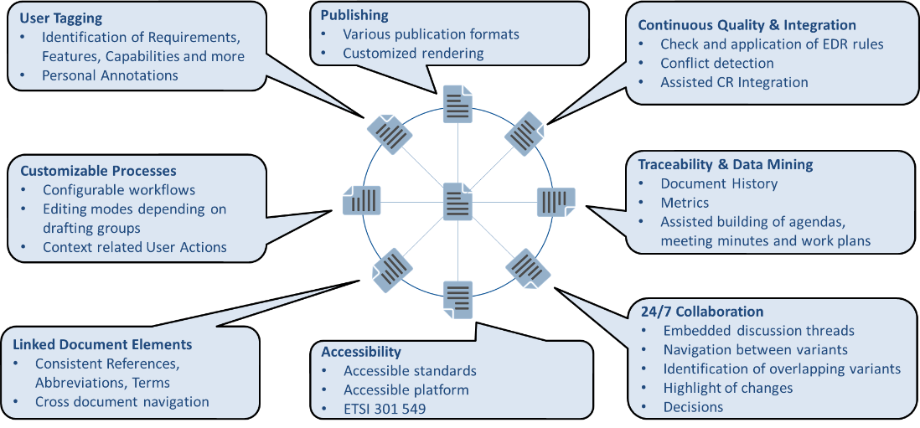Customizable: can be configured for 3GPP’s process (well-defined) or the various process used in ETSI committees, with different roles, rights and document life-cycles.

# Constraints & Alternatives

*Basic constraints:*

* No per-user license fees – ETSI and 3GPP have thousands of users (delegates) so costs quickly become an issue;
* No software installation required – our members’ corporate IT policies often forbid installation of non-authorized software;
* Enabling the standards development workflow: In standards development, delegates create independent contributions or proposals to change a standard (Change Requests), which are each shared, discussed, modified. Once approved, they are integrated into the baseline specification, creating a new version. All changes must be traceable, indefinitely.

*Microsoft Word with OneDrive and Google Docs / G-Suite:* these provide shared concurrent editing of a single document, with traceability of changes provided within a document, but no meta-data about reason for change etc. This is not the required editing workflow.

*Content Management Systems:* Numerous tools exist around information sharing platforms, allowing common access to documents, discussion threads, issue cards, persistent chat etc. These do not enable our editing workflow. They may also require per-user licensing. The same applies for requirements management solutions (often requiring desktop software installation).

*Open Source Software code management platforms and Markdown text:* These require familiarity with code management principles as they are based around Git repositories. The markdown editors are basic. They do not provide the required configurability for customizable processes.